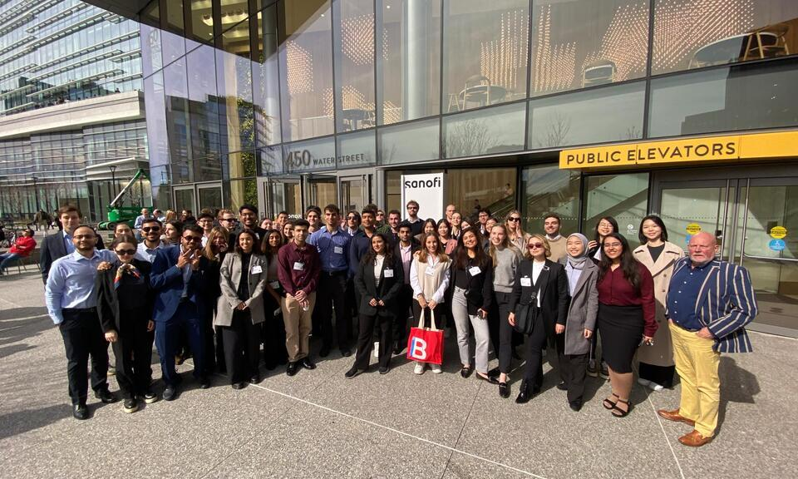
Zenvogo Global Immersion Programmes
Learn Beyond Borders. Experience the World.
We design and deliver international and domestic immersion experiences that connect academic learning with global industries, leading institutions, cultural perspectives and real-world opportunities.
1. Homepage – Immersion programme section
Global Immersion Programmes
Take learning beyond the classroom with thoughtfully designed academic and industry immersion experiences across international destinations.
Zenvogo partners with universities, educational institutions and organisations to create meaningful learning journeys that combine academic sessions, corporate interactions, institutional visits, cultural experiences and professional networking.
Whether it is exploring Europe's business landscape, experiencing India's emerging industries, understanding Vietnam's fast-growing economy, discovering Malaysia's multicultural business environment or engaging with Dubai's global business ecosystem, every programme is designed to create a lasting learning experience.
Our approach combines:
- Academic sessions with international faculty and industry experts.
- Corporate visits and real-world business exposure.
- University interactions and institutional collaborations.
- Cultural exploration and experiential learning.
- Professional networking and peer engagement.
- End-to-end programme planning and coordination.
2. Our Global Destinations
Europe – Business, Innovation & Global Perspectives
Explore Europe's diverse business environment through university engagements, academic interactions, corporate exposure and cultural experiences.
Potential learning themes:
- International business and management
- Luxury, fashion and brand management
- Finance and global markets
- Innovation, entrepreneurship and sustainability
- European business and cultural ecosystems
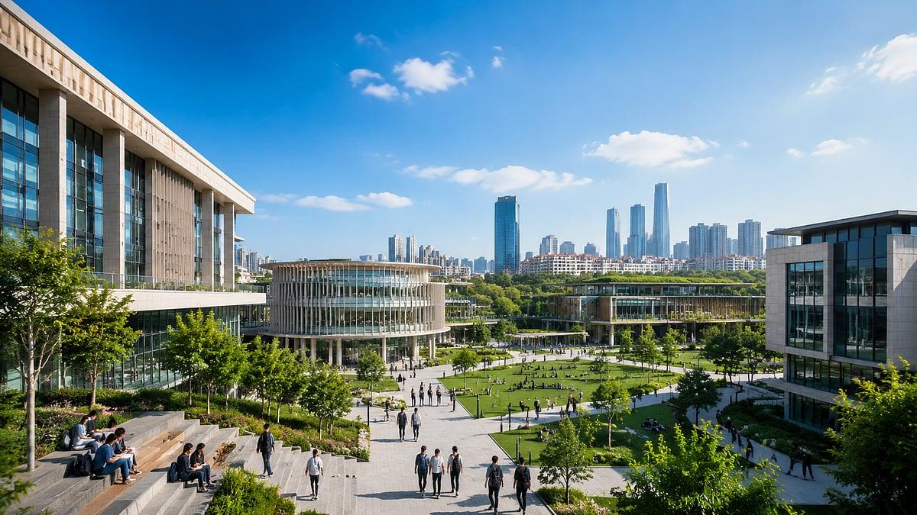India – Emerging Markets & Business Transformation
Understand India's dynamic economic landscape through industry interactions, academic engagements and exposure to one of the world's most diverse business environments.
Potential learning themes:
- Entrepreneurship and start-up ecosystems
- Digital transformation and technology
- Banking and financial services
- Manufacturing and supply chain
- Healthcare and business operations
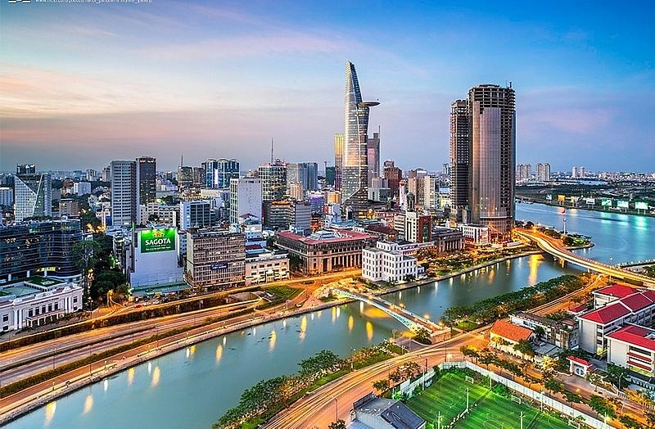Vietnam – Growth, Manufacturing & Entrepreneurship
Experience one of Southeast Asia's evolving economies and explore its growing role in global trade, manufacturing and innovation.
Potential learning themes:
- International trade and business
- Manufacturing and supply chain management
- Entrepreneurship and start-up ecosystems
- Emerging market strategies
- Economic development and sustainability

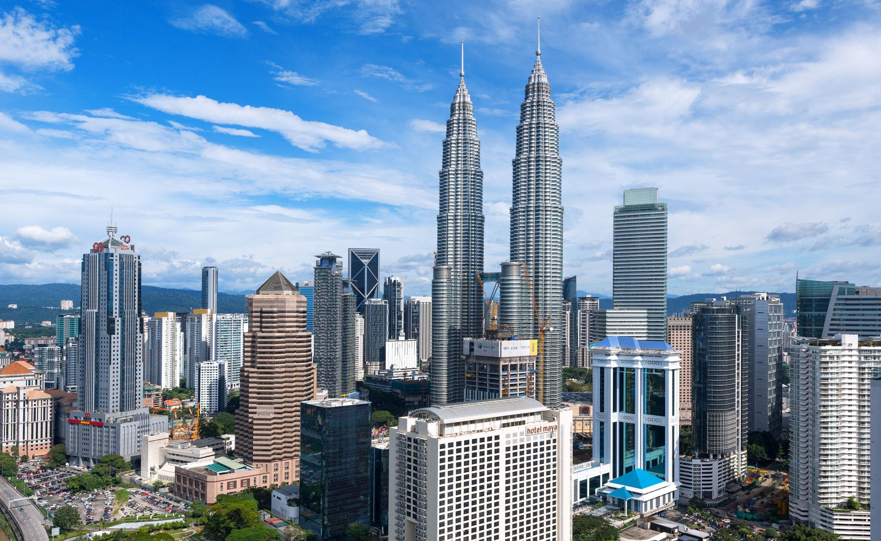Malaysia – Multicultural Business & Regional Opportunities
Discover Malaysia's position as a regional business hub through institutional engagements, industry exposure and cross-cultural learning.
Potential learning themes:
- International business and trade
- Islamic finance and banking
- Tourism and hospitality management
- Technology and digital business
- Multicultural leadership and management
Dubai – Global Business, Innovation & Entrepreneurship
Explore Dubai's international business ecosystem, where global commerce, innovation, entrepreneurship and diverse industries converge.
Potential learning themes:
- Global trade and international business
- Real estate and infrastructure
- Finance and investment
- Entrepreneurship and innovation
- Luxury, tourism and hospitality
3. What Makes a Zenvogo Immersion Experience Different?
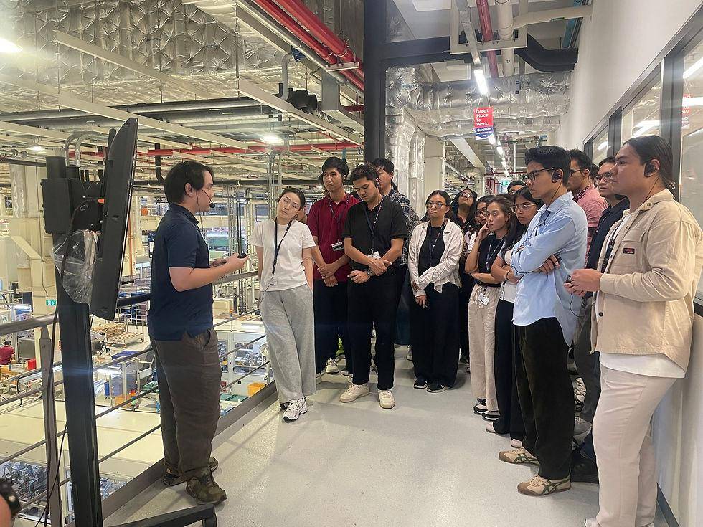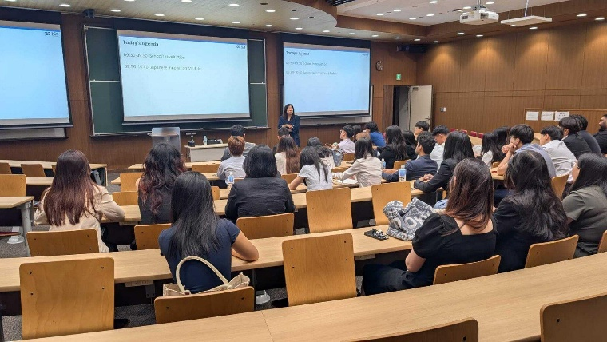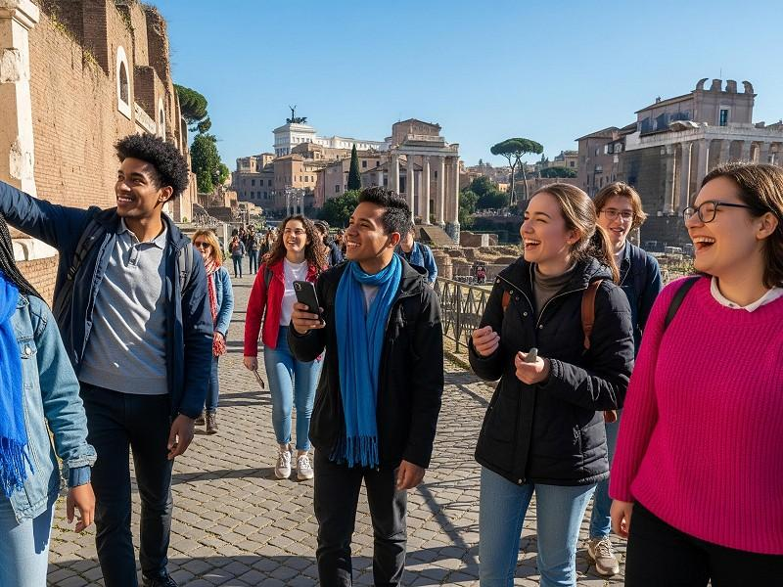
10
Learning that connects knowledge with experience.
Every immersion programme is developed around a carefully planned learning framework.
Experience | What participants gain
Academic engagements | Insights from university faculty and subject experts
Industry exposure | Understanding of business operations and industry practices
Corporate interactions | Perspectives from business leaders and professionals
Institutional visits | Exposure to international education and innovation ecosystems
Cultural experiences | Understanding of local traditions and global perspectives
Networking | Opportunities to connect with peers and professionals
4. Our Programme Formats
We understand that every institution and organisation has different learning objectives. Zenvogo offers flexible programme formats.
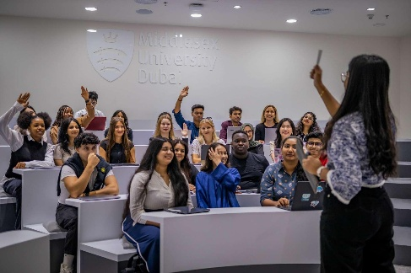
Academic Immersion Programmes
Short-term international and domestic academic experiences designed around specific disciplines, management themes and institutional learning objectives.

Executive & Leadership Immersions
Experiential learning journeys for senior professionals, managers and business leaders, combining faculty interactions and corporate exposure.

Industry & Corporate Immersions
Sector-specific programmes offering insights into industries, business models, operational practices and emerging technologies.
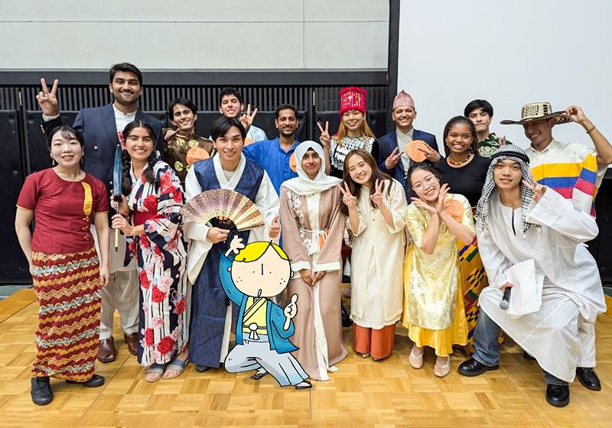
Customised Institutional Immersions
Bespoke programmes for universities, business schools and educational institutions, tailored to their academic calendars and cohort requirements.
5. Our End-to-End Programme Management
From programme concept to on-ground execution, we manage the details.
Zenvogo supports institutions and organisations throughout the immersion lifecycle.
- Programme Conceptualisation
Understanding learning objectives, participant profiles, destination preferences and programme requirements.
- Academic & Industry Partnerships
Identifying universities, faculty, industry experts and corporate engagement opportunities.
- Itinerary & Experience Design
Developing a structured schedule of academic sessions, visits, networking and cultural experiences.
- Travel & Logistics Coordination
Coordinating accommodation, ground transportation, meals and local programme arrangements.
- On-Ground Programme Management
Managing participant coordination, programme schedules, institutional interactions and execution.
- Programme Closure & Feedback
Gathering participant feedback, documenting outcomes and identifying opportunities for future programmes.
6. Who We Work With
- Universities and business schools
- Higher education institutions
- Online and executive education providers
- Corporate learning and development teams
- Industry associations and professional bodies
- Student groups and professional cohorts
7. Why Choose Zenvogo?
Global exposure. Thoughtful design. Seamless execution.
- Curated experiences: Programmes built around specific learning outcomes rather than generic travel itineraries.
- Global network: Access to academic institutions, industry experts and corporate engagement opportunities.
- Customised approach: Experiences designed around the needs of each institution and cohort.
- End-to-end coordination: A single programme partner supporting planning and execution.
- Meaningful outcomes: A focus on practical insights, professional connections and cross-cultural understanding.
8. Call to Action
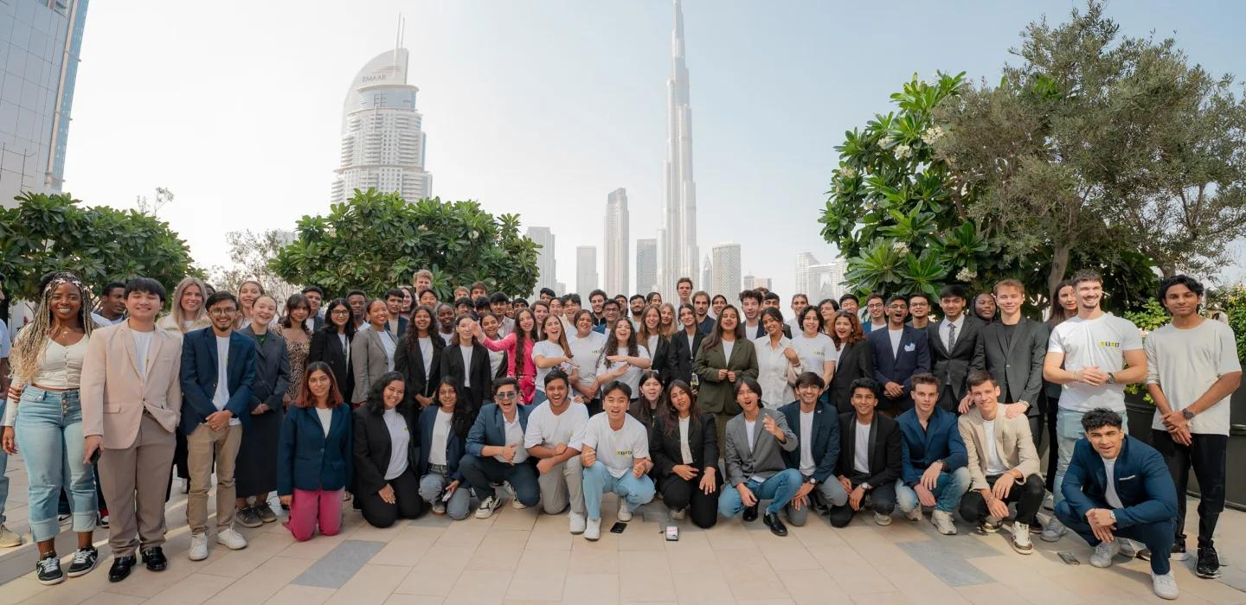Let's Create Your Next Global Learning Experience.
Whether you are a university planning an international immersion, a business school looking to expand experiential learning, or an organisation developing global leadership capabilities, Zenvogo can help bring your vision to life.
Let's design an immersion programme that makes learning travel further.
Enquire About an Immersion Programme

